**Sprint 2 Planning:** GotoGro-MRM

**Team Details**

|  |  |
| --- | --- |
| **Team Name:** | MSP 14 |
| **Tutorial:** | Tue 2:30 ATC325 |
| **Tutor:** | Dr Kaberi Naznin |

|  |  |
| --- | --- |
| **Members:** | |
| Dylan Jarvis | 102093138 |
| Rabya Tayal | 103144215 |
| Simon Tran | 103602807 |
| Thomas Babicka | 103059885 |
| Cody Cronin-Sporys | 103610020 |
| Nicholas Dyt | 101624265 |

**Sprint 2 Day 0 Trello Board**

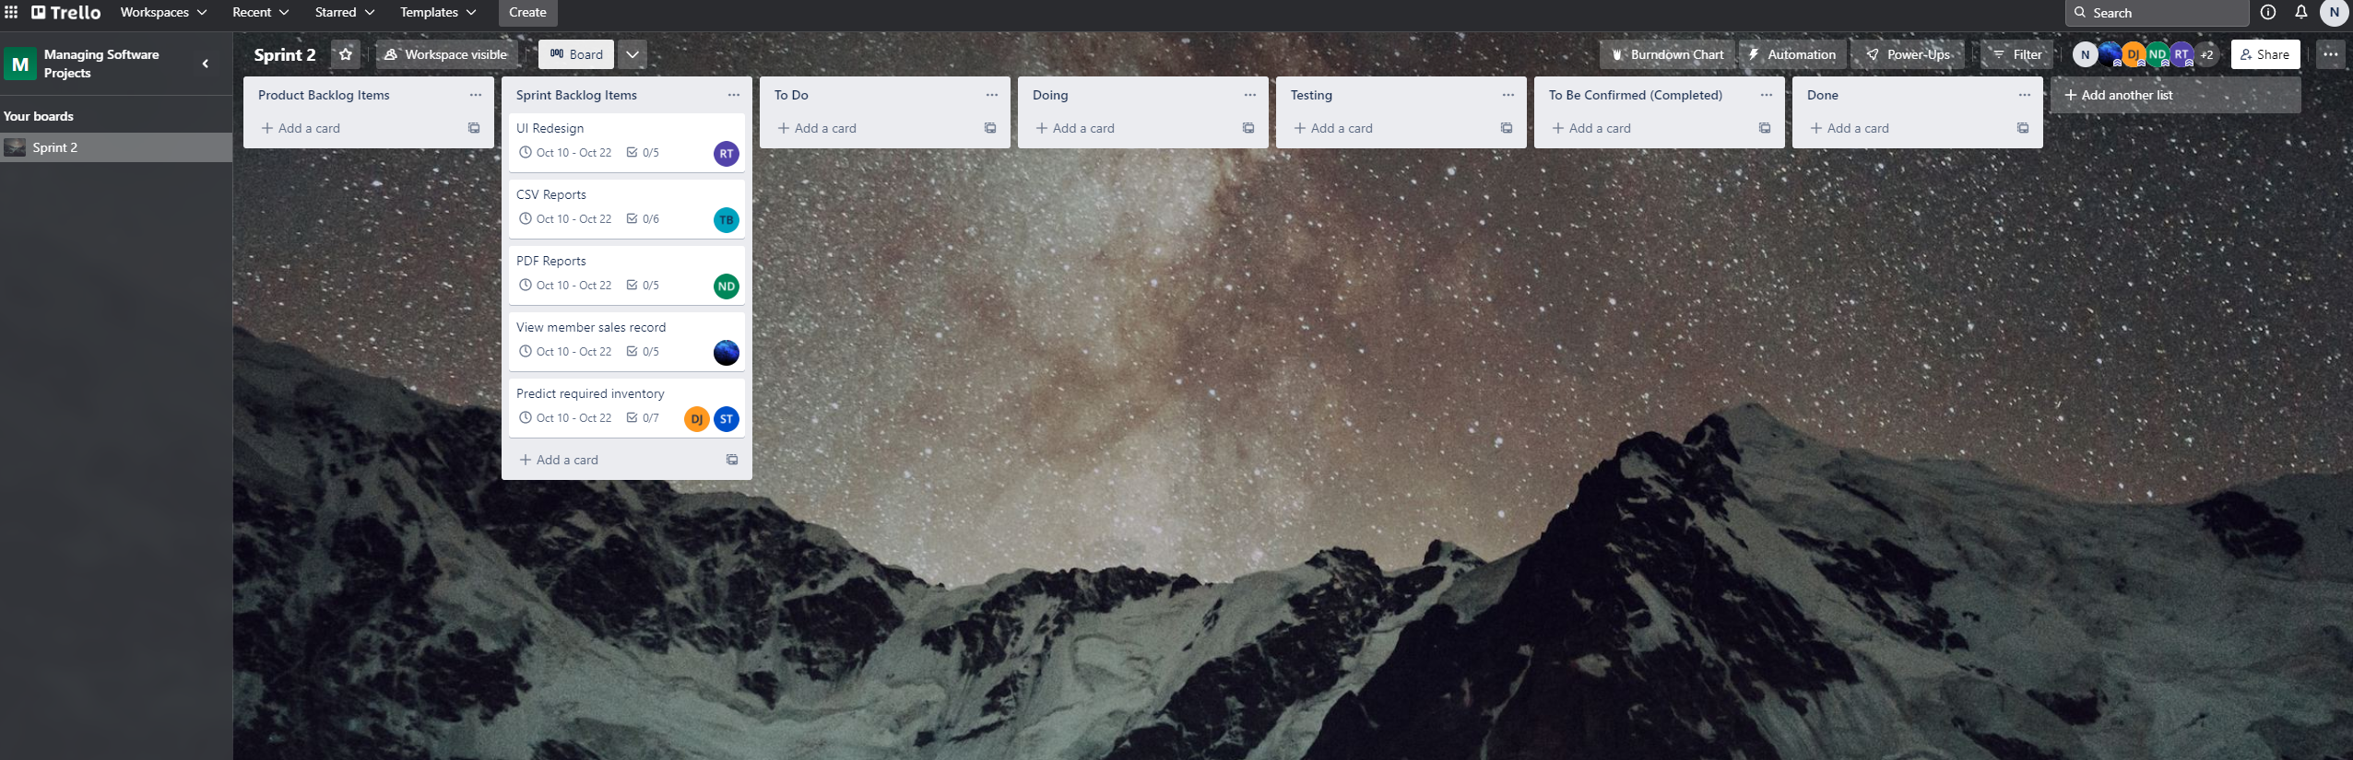

**Sprint 2 Day 0 GitHub Repo**

